<http://www.ayambakarrojo.com/>

GMAIL ACCOUNT

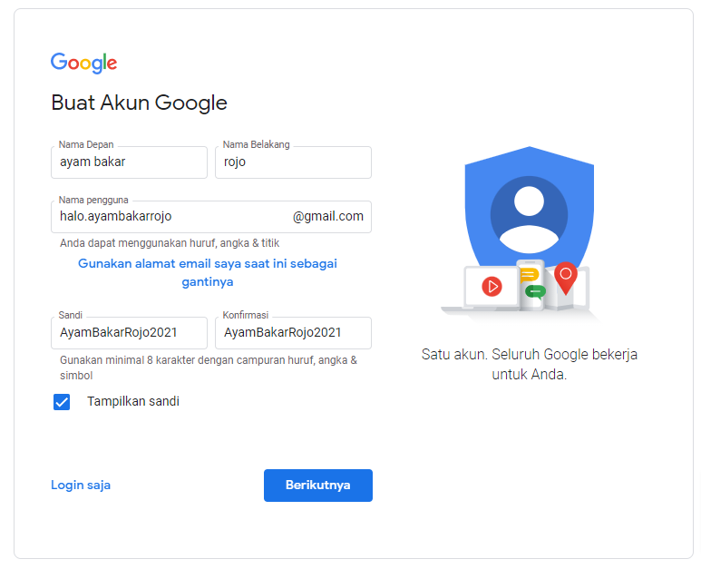

halo.ayambakarrojo@gmail.com

AyamBakarRojo2021

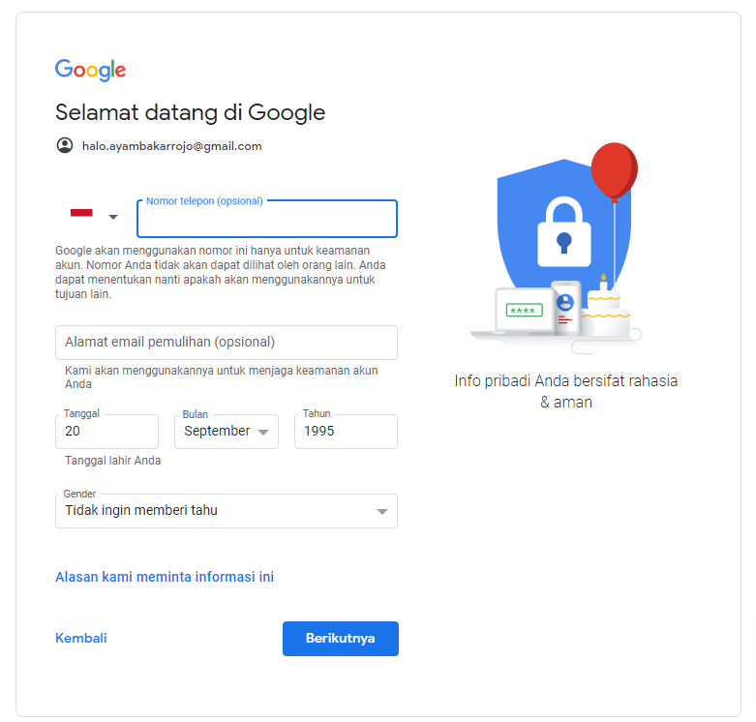

<https://member.jagoanhosting.com/register.php>

